# SharePoint Online Connector for OpenText Capture Center

The SharePoint Online connector support SharePoint Online, SharePoint 2013 and newer SharePoint versions. It uses the [Client Side Object Model](https://msdn.microsoft.com/de-de/library/ff798388.aspx) (CSOM) to talk to SharePoint. The connector’s UI provides settings grouped into four tabs.

## Connection Tab

The connection tab allows to define how to connect to the SharePoint system.

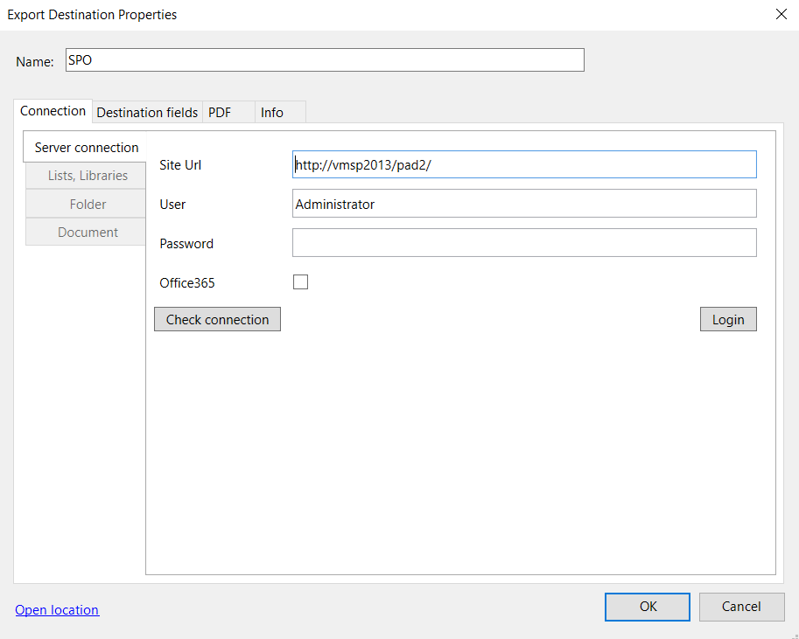

The Site Url is can be copied from the address line of your browser. Note however that it is only the first part of the Url, e.g. from *https://opentext.sharepoint.com/sites/occ/SitePages/Home.aspx* you must only take the part marked in red.

User and password fields take the users credentials. Check the Office365 box if you are connecting to SharePoint online. Hitting Login will log you into the SharePoint system and will activate the List and Libraries tab.

The Check connection button tries to connect to the specified system and returns a status. Please note that the first of the three action may fail while the other two succeed. The first is a Ping operation and some systems do not respond to the ping call.

## List, Library Tab

On the List and Library tab you select the list or library where your documents should be stored. You select the columns that should be mapped to OCC fields and you select the culture by which the fields values captured from OCC should be interpreted.

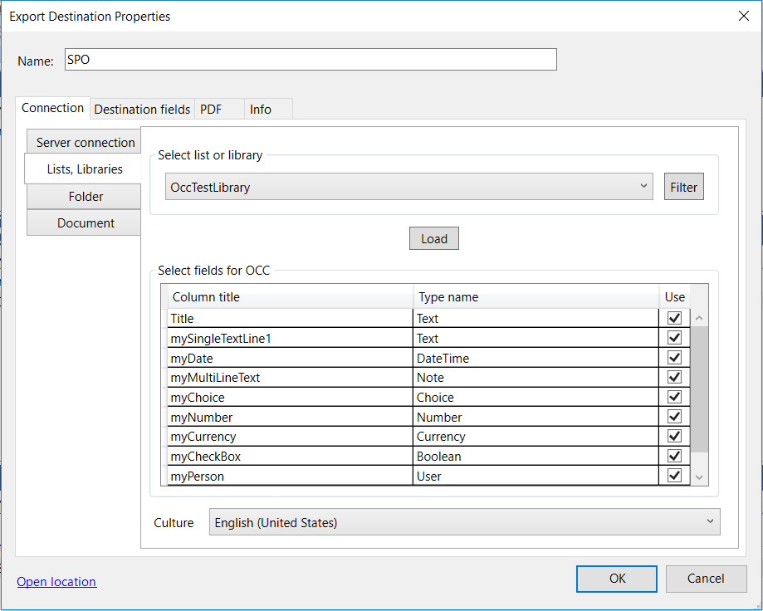

The drop-down list on the top lets you select the list or library. Which lists and libraries are shown in the drop-down list is controlled by a filter that can be specified by hitting the Filter button. Once you’ve selected the list or library you hit the Load button which reads the properties off the list or library and loads them into the table. Each property can be selected or deselected. Only the selected ones will be mapped to OCC fields.

There are more than 100 properties connected to a list or library in SharePoint. Most of them are for internal use and it will make no sense to set them from document values, besides being impossible for many of them. OCC applies a filter to the properties selecting only the ones that are not marked as read-only and that are not marked as hidden. Typically, this filter will deliver only custom columns. A special case is the Title property which is always shown in the property list.

There might be cases where you want to set a list or library property not provided as default by OCC. In this case you can you the filter definition to specify the field’s name and it will show up. However, if the field is read-only or cannot be set by vie the Client Side Object Model API the document export may fail.

## Field Formats

The drop-down list at the bottom of the Lists and Libraries tab lets you specify the culture by which the values of certain property types are interpreted. The property types controlled by the DateTime, Numeric and Currency. The value in these fields is parsed with the associated .net function which therefore defines the allowed values. The value of all other fields is taken literally and SharePoint defines whether the OCC’s field value is accepted. You need to ensure through either fields types in OCC (regular expressions) or through business rules (scripting) that the values in those fields are acceptable to the SharePoint system. E.g. the value of a field of type Choice must be among the entries allowed for this field.

Special treatment is given for empty fields if they belong to the types controlled by the culture. If OCC delivers an empty string as a value for that field, it is not transferred to SharePoint. In that case SharePoint will use the default value. The DateTime field is furthermore reduced to a date, if there is a true DateTime value delivered by OCC (e.g. *03/15/2017 10:00 PM*) it is accepted but the time part is ignored. The reason is that if client and server run in different time zones the interpretation of the value may lead to surprises, e.g. a date change.

## Filters

Selection of list and libraries by the connector are controlled by a filter. This filter can be changed by hitting when the Filter button is hit. A dialog is launched that has four tabs.

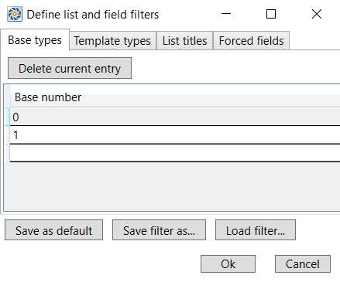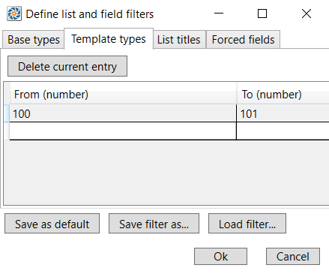

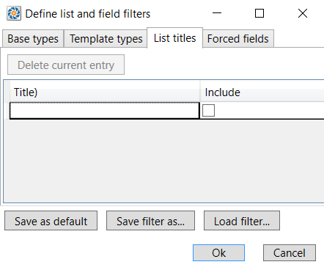 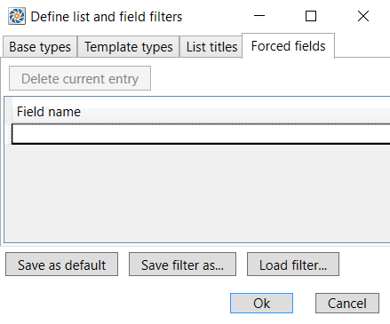

On the Base types tab you can specify which base types the list or library must have so that OCC provides it in its drop-down list. The default values 0 and 1 stand for Generic list and Library. A documentation of the different values can be found on [here](https://msdn.microsoft.com/en-us/library/microsoft.sharepoint.client.basetype.aspx) on MSDN.

On the Template types tab you can specify which template types OCC should pick from. These can be ranges because there may be custom lists in certain number areas. The default values again cover Generic list and Library. A documentation of the different values can be found on [here](https://msdn.microsoft.com/de-de/library/microsoft.sharepoint.splisttemplatetype.aspx) on MSDN.

On the List Title tab you can specify specific lists or libraries by name. The value in Title is taken as a regular expression. (The complete title of a list or library is a valid regular expression matching exactly that list or library). If the Include checkbox is checked those lists and libraries matching the regular expression are included in the drop-down list otherwise they are excluded.

The forced fields tab lets you specify list or library properties by their name. They will be included in the field list for OCC as described above.

The currently selected entry can be deleted using the Delete current entry button on each tab.

With the Save as default button the current filter settings will become the default for all future SharePoint online connectors created on your machine. The *Save filter as…* button stores the filter settings as an XML file. The *Load filter..* button loads a filter definition from a file. Together they allow you to distribute the filter from one machine to another.

## Folder Tab

The folder tab lets you specify whether the document should be stored in a sub folder of the selected list or library and if so, how the folder should be determined.

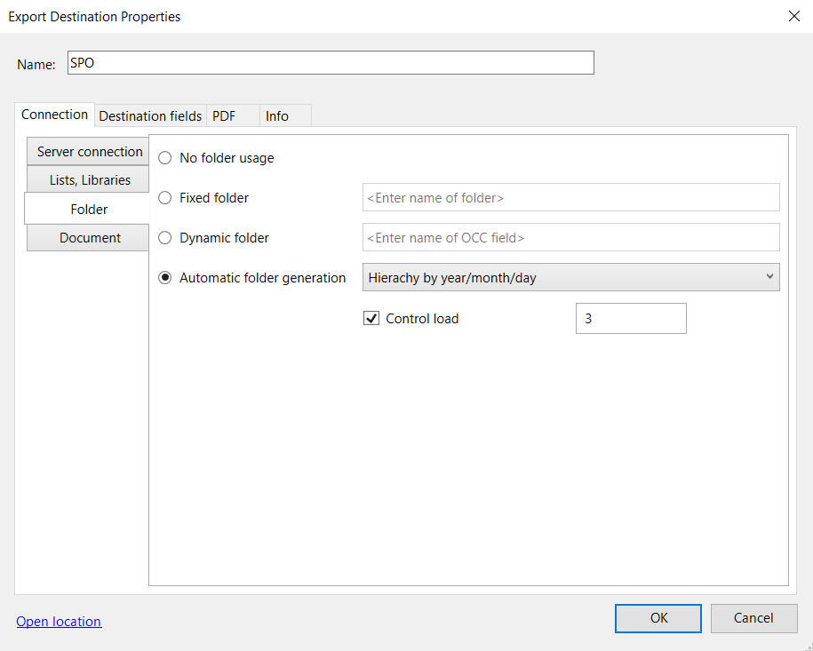

There are four options to choose from:

* **No folder usage**: Stores the documents in the root folder of the list or library.
* **Fixed folder**: Stores the document in the folder specified in the entry field.
* **Dynamic folder**: Take the folder name from the OCC field whose name is given in the entry field.
* **Automatic folder generation**: Automatically generate folder names bases on a rule.

The folder name may include subfolders, e.g. *folderA/folder*. Slashes should be omitted at the beginning and at the end.

## Automatic folder generation

There are three option to choose from:

* **Hierarchy by capacity**: Files are written to a subfolder with the name given in the *Basefolder name* input field. Each time the number of items in a folder reaches the threshold defined by the property Maximum capacity, a new subfolder is created. A number is added to each folder like *_0042*; the numbering starts with 0.
* **Hierarchy by day**: Output files are written to a new subfolder with the name <year>-<month>-<day> each day. Additional properties permit to restrict folder size. If you select the *Control load* check box, a new subfolder is created as soon as the number of items in the current folder reaches the threshold defined by the property Maximum capacity. For these folders, the number is added as described above.
* **Hierarchy by year/month/day**: A folder hierarchy is created: A folder for the current year containing a subfolder for the current month and a subfolder for the day to which all output files are written to during this day. Folder load can be controlled like in the above cases.

## Document Tab

On the Document tab, you specify the format of the output filenames.

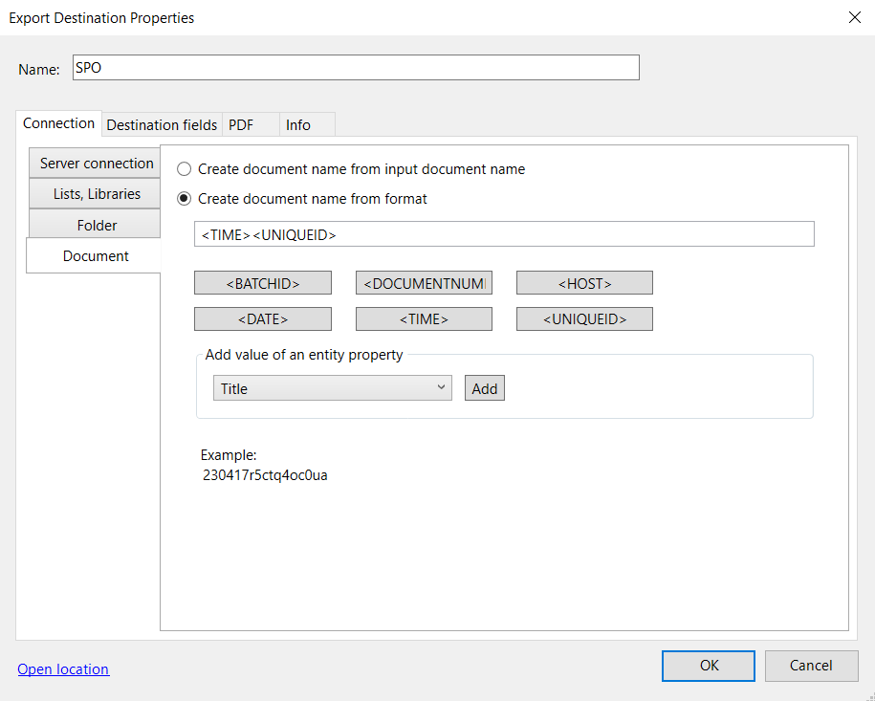

By default, the filename comprises the batch ID and the document number within the batch. To modify the filename specification:

* Remove placeholder strings as needed.
* Enter characters in the text box as needed. These characters will appear unmodified in all filenames.
* Click the respective buttons to add placeholders to the specification.
* To add the value of an entity property, click the property in the entity property list, and then click Add.

An example string always shows a filename according to the current specification.

To use the input filename click *Create document name from input filename*.